SUMS TO DO..

1. THE CLTF of a system is 

Find the nature of the system by finding its damping ratio.

A step change of magnitude 6 is introduced into the system.

Find the respective error constant and the steady state error.

2. Comment on the system & find the respective error constant and the steady state error

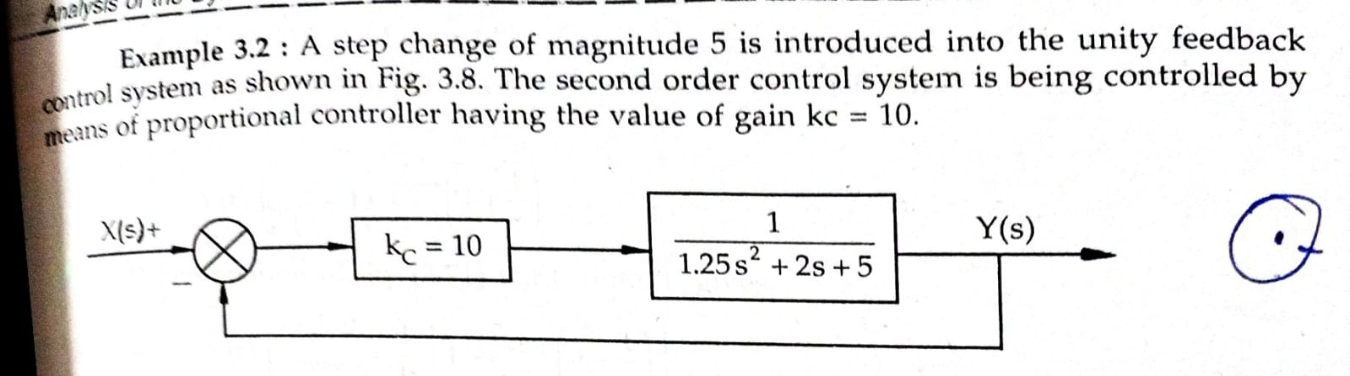

3. THE CLTF of a system is 

A ramp input is introduced into the system.

Find the respective error constant and the steady state error.

4. 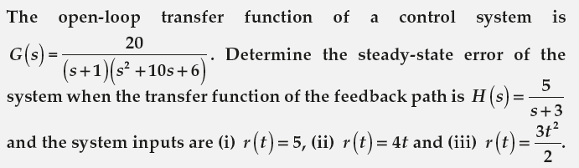

5. THE CLTF of a system is 

A Parabolic input is introduced into the system.

Find the respective error constant and the steady state error.